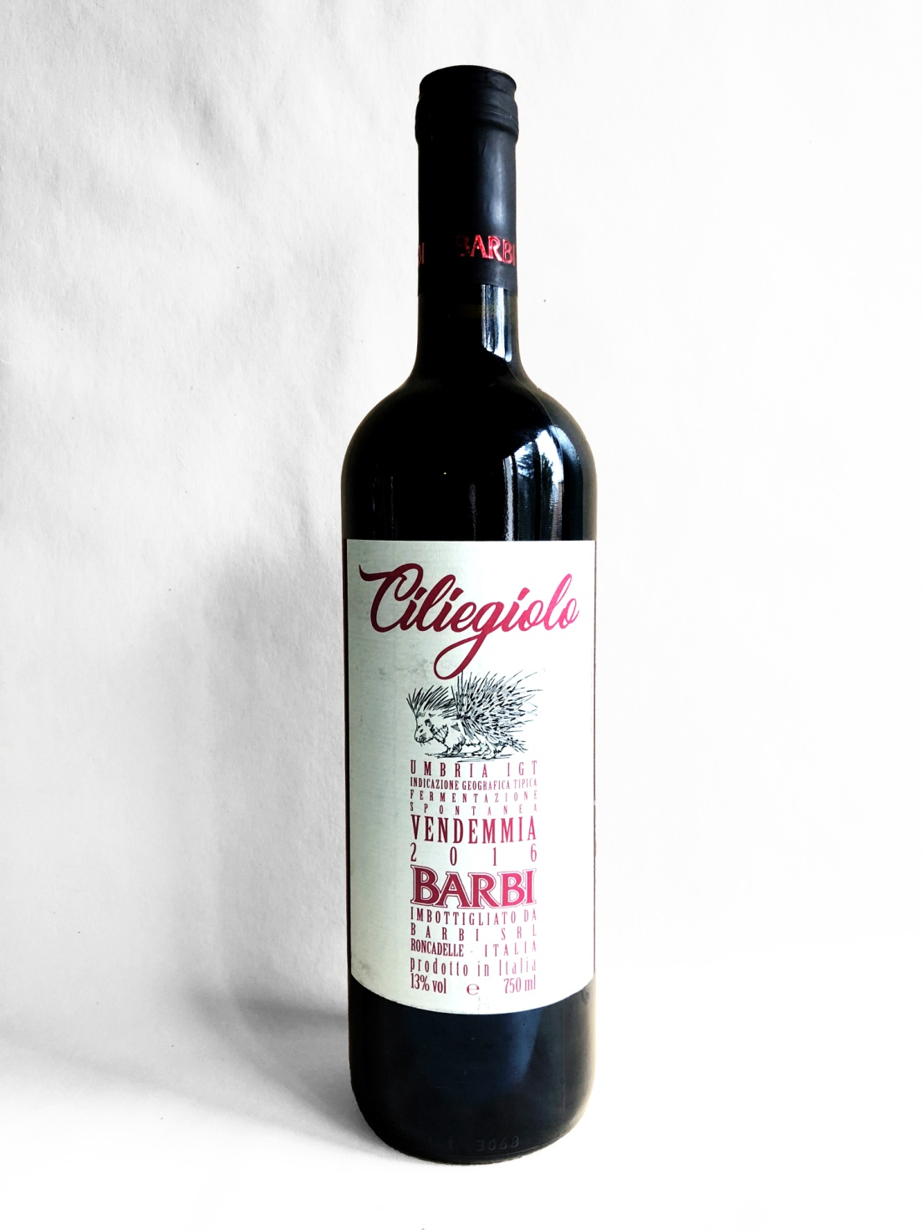 | Tenuta in Baschi  CILIEGIOLO UMBRIA IGT 2018  TYPE OF WINE: fruity red wine with an elegant tannin for medium to long aging  THE GRAPES: Ciliegiolo 100%  VINIFICATION: the fermentation develops spontaneously in stainless steel vats, with no yeasts added, the maceration on the skins lasted about 14 days.  REFINING: in underground cellars at a controlled temperature, in stainless steel vats at first and then in French oak barrels for 6 months, lastly in bottle for 2 months.  ALCOHOLIC CONTENT: 13 % vol.  TOTAL ACIDITY: 5, 4%  COLOR: ruby red  BOUQUET: intense, pleasant and fruity characterized by a strong cherry scent and a fragrant bouquet of red fruit.  TASTE: round, rich and soft  COMBINATIONS: it goes very well with cold cuts, first courses with meat sauces and roasted white meat dishes.  CONSUMPTION: at its best starting from its second year  POURING TEMPERATURE: 18° C.  FORMAT: 750 m

