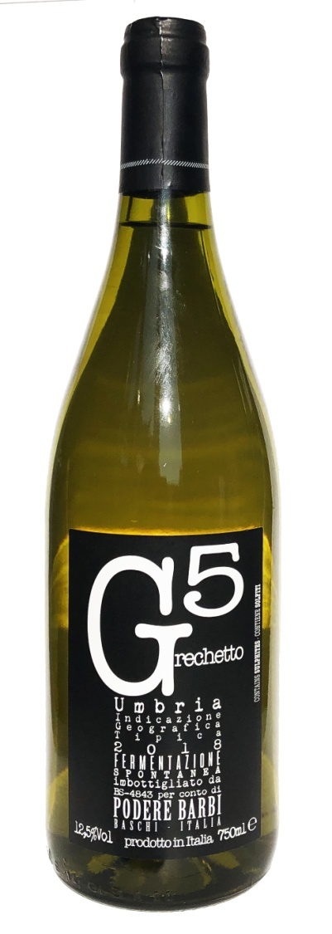 | Tenuta in Baschi  GRECHETTO UMBRIA IGT 2019  TYPE OF WINE: structured white wine  THE GRAPE: 100% Grechetto G 5  VINIFICATION: the fermentation develops spontaneously in stainless steel vats, with no yeasts added, at controlled temperature  ALCOHOL: 13.5 % by volume  TOTAL ACIDITY: 6.15 ‰  COLOUR: straw yellow with golden reflections  BOUQUET: fragrant, intense , with remarkable delicacy and notes of citrus  TASTE: mineral, with good structure and pleasantly fresh  COMBINATIONS: excellent with seafood appetisers, soups, first courses and soft cheese  CONSUMPTION: evolves optimally for 2-3 years  POURING TEMPERATURE: 10°-12°C  FORMAT: 750 ml

