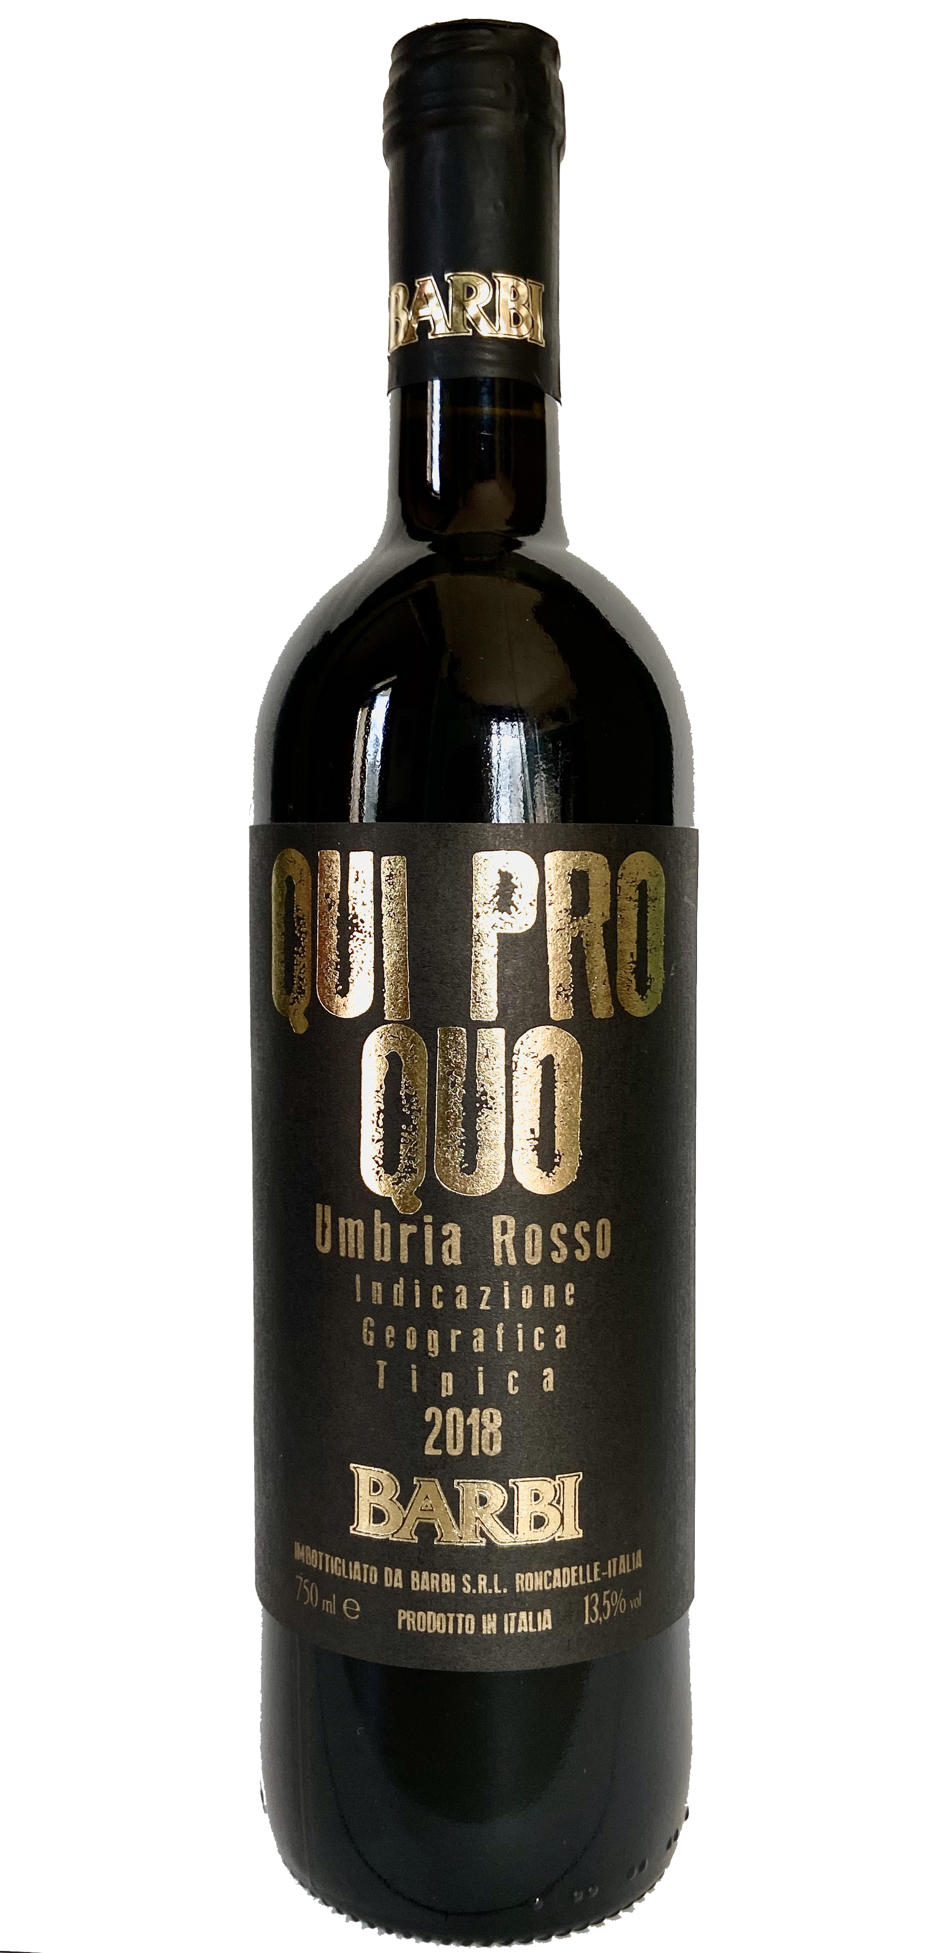 | Tenuta in Baschi  QUI PRO QUO UMBRIA IGT 2018  TYPE OF WINE: smooth red for medium aging  THE GRAPES: 50% Montepulciano, 50% Sangiovese  VINIFICATION: in stainless steel vats, the maceration on the skins lasted 12 days  ALCOHOL: 13.5 % by vol.  TOTAL ACIDITY: 5,30 %o  RESIDUAL SUGAR : 7 gr/l  COLOUR: deep ruby red  BOUQUET: with hints of ripe undergrowth fruits  TASTE: smooth, harmonious right body  COMBINATIONS: easily goes with various dishes but particularly with roasts, game, cold cuts and seasoned cheese  CONSUMPTION: excellent for immediate drinking, although it keeps well for about three years  POURING TEMPERATURE: 16° - 18° C.

